Indradeep Bhattacharya

Roll No: T2017-1072, Registration Number: A4734 of 2017-18

Paper Name: Information System Design Laboratory

Paper Code: CSE-753

Abstract

An online food ordering system can be defined as software that allows restaurant businesses to accept and manage orders placed over the internet. ... First is a website or mobile app for hungry customers to view the restaurant's dishes and place an online order.

Online Food delivery information system

Food Delivery Application

Online Food Delivery Information System

Indradeep Bhattacharya1, Sayandeep Basu2, Sankalpa Chowdhury3

1, 2, 3 University Institute of Technology, The University of Burdwan, WB, Pin:713104, India

[indra485@gmail.com](mailto:indra485@gmail.com)1, [sayandeepbasu8199@gmail.com](mailto:sayandeepbasu8199@gmail.com)2, [sankalpachowdhury11@gmail.com](mailto:sankalpachowdhury11@gmail.com)3

Roll No1: T2017-1072, Reg. No1: A4734 of 2017-18

**Abstract.** An Online Food Delivery System is a system which will assist restaurant to optimize and control over their restaurants. For the waiters, it is making life easier because they do not have to go kitchen and give the orders to chef easily. For the management point of view, the manager will able to control the restaurant by having all the reports to hand and able to see the records of each employees and orders. This application helps the restaurants to do all functionalities more accurately and enhances the spend of all the tasks. Online Food Delivery System reduces manual works and improves efficiency of restaurant. The online food delivery system set up menu online and the customers easily places the order with a simple mouse click. Also, with a food menu online you can easily track the orders, maintain customer's database, and improve your food delivery service. This system allows the user to select the desired food items from the displayed menu. The user orders the food items. The payment can be made online or pay-on-delivery system. But due to this pandemic, we have decided to make our payment method online. The user’s details are maintained confidential because it maintains a separate account for each user. An id and password are provided for each user. Therefore, it provides a more secured ordering.

1. Introduction

In existing system for giving any orders, users should visit hotels or restaurants to know about food items and then give order and pay advance. In this method, time and manual work is required. Maintaining critical information in the files and manuals is full of risk and a tedious process. In this pandemic situation, it is very perilous to travel to a restaurant to order some food. In this context, we are going to develop an android based food delivery system with affordable cost.

1. Proposed System

This online application enables the end users to register online, select the food from the e-menu card, read the e-menu card and order food online. By just selecting the food that the user wants to have. The results after selecting the food from the e-menu card will directly appear in the screen near the chef who is going to cook the food for you. By using this system, the work of the waiter is reduced and we can also say that the work is nullified. The benefit of this is that if there is rush in the restaurant then there will be chances that the waiters will be unavailable and the users can directly order the food to the chef online by using this system. The user will be given a username and a password to login.

* 1. Intended Audience

Most of the online food delivery demands come from the age group of 18-40 years whereby 65 % of the target market are below 35 years of age.

* 1. Intended Use

It also enables customers to enjoy quality food at their favorite store or restaurant without needing to leave the comfort of their home. Because of its added convenience to customers, food delivery is something you can venture into in the world of business.

* 1. Customer Needs

The necessary information needed by customers referenced underneath:

* + - Menu
    - Menu Description
    - Price
    - Delivery Time

1. Functional Requirements
   * + **Registration:** If customer wants to order the food then he/she must be registered, unregistered user cannot go for ordering.
     + **Login:** The customer login to the system by entering valid user id and password for ordering.
     + **Display the Menu:** In the system all the items are displayed with their rates.
     + **Modify Menu:** System can make changings in menu like adding or removing food items which are not available.
     + **Select Food Items:** Items are selected customer feel free to order.
     + **Changes to Order:** Changes to order means the customer can make changings in order like he/she can delete or add food item in order.
     + **Review the Order Before Submitting:** Before submitting the complete order is reviewed to the customer. Customer name, phone number, location (address) and placed order, hen finally order is submitted.
     + **Payment:** For the customer there are many types of secure billing will be prepaid as debit or credit card, postpaid as after delivering.
     + **Logout:** After the payment or surf the product the customer will log out.
2. Non-Functional Requirements
   * + **Portability:** System running on one platform can easily be converted to run on another platform.
     + **Reliability:** The ability of the system to behave consistently in a user-acceptable manner when operating within the environment for which the system was intended.
     + **Availability:** The system should always be available, that means the user can access it using a web browser, only restricted by the down time of the server on which the system runs.
     + **Maintainability:** A commercial database is used for maintaining the database and the application server takes care of the site.
     + **Security:** Secure access of confidential data (customer information).
     + **User-Friendly:** System should be easily used by the customer
     + **Performance:** Performance should be fast
     + **Efficiency:** System should be efficient that it will not get hang if heavy traffic of order is placed.
     + **Safety:** Data in the database of system should not loss or damage.
     + **Privacy:** Personal data of the system should not disclose to anyone.
3. Technology and Programming Languages Used
   * + Android Studio 4.1.1
     + Java Programming Language
     + Extensible Markup Language (XML) to create layout files.
     + Firebase Technology as Database to store records.
4. Innovative Thinking

Just the way people realized that they are confined to their homes but they can order their food with just a few clicks, confines are also the reason people around the globe choose more mobile food delivery apps. Below we have discussed some justifications as to why our mobile food delivery application is more necessary and helpful amid COVID-19:

* + - To Keep the Economy Alive
    - Trying to Mitigate Food Businesses from Shutting Down
    - Restaurant Mobile Apps - A Huge Lifesaver
    - Our Food Delivery Application promotes Social Distancing
    - Helps elderly people to order food
    - Food Quarantine Facility
    - Social Responsibility

1. Data Flow Diagram

In this section, we have shown the 0-level and 1-level DFD of our android application named “O. Restaurant”.

* 1. 0-Level DFD

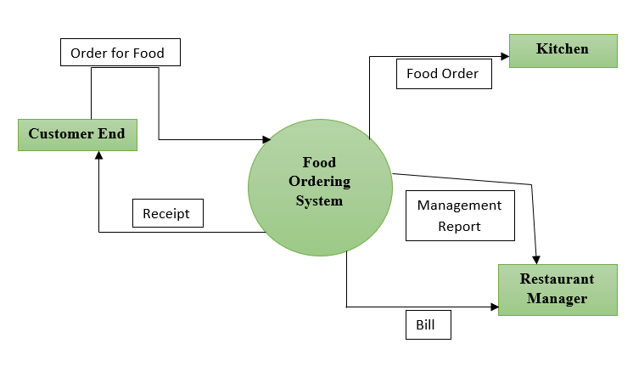

* 1. 1-Level DFD

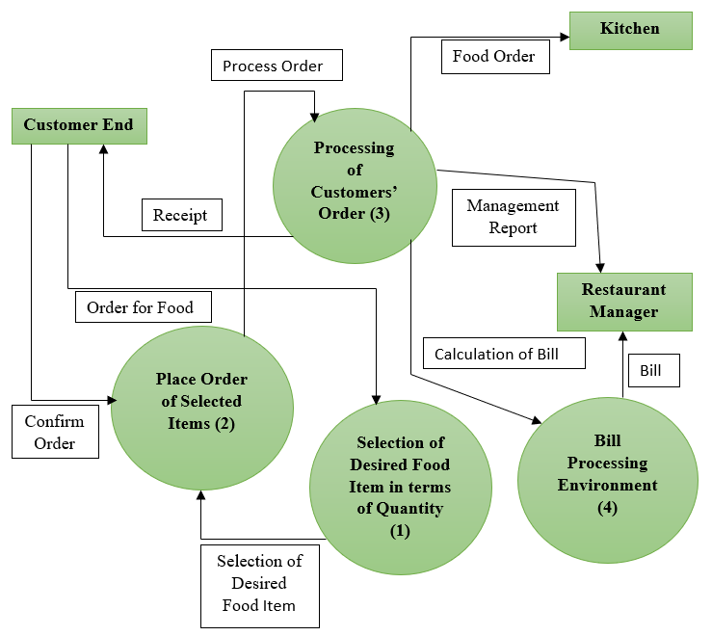

1. Unit Testing Phase

We have developed the main interface of the food delivery system i.e., desired order selection, the quantity of the desired item, place order, and the computation of the total amount. We have tested every unit / part i.e., whether a customer can select an item from the list of items, whether the place order function or method works or not, whether the computation of the total amount based on a customer’s request has displayed correctly or not etc. The figures referenced underneath demonstrates the working of each unit in this android application.

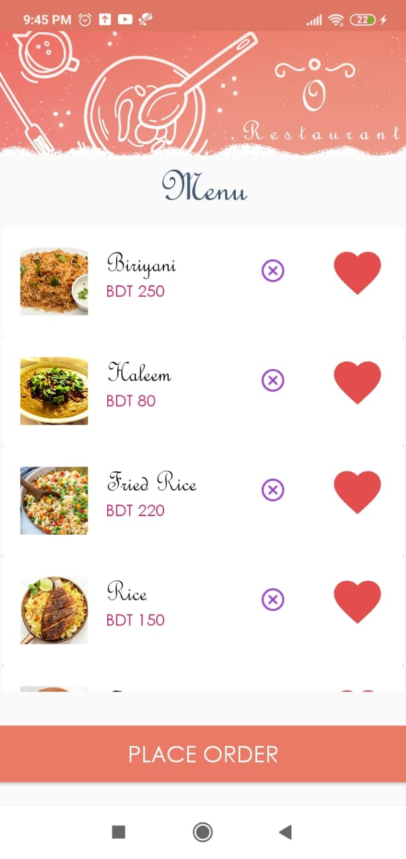

**Fig. 1.** Item List (Foods) for the Customer

.

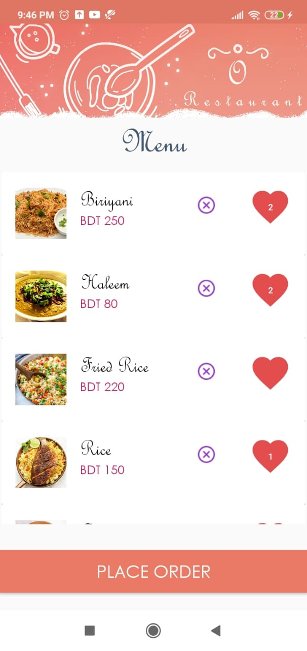

**Fig. 2.** Select Quantity for each Item in the List

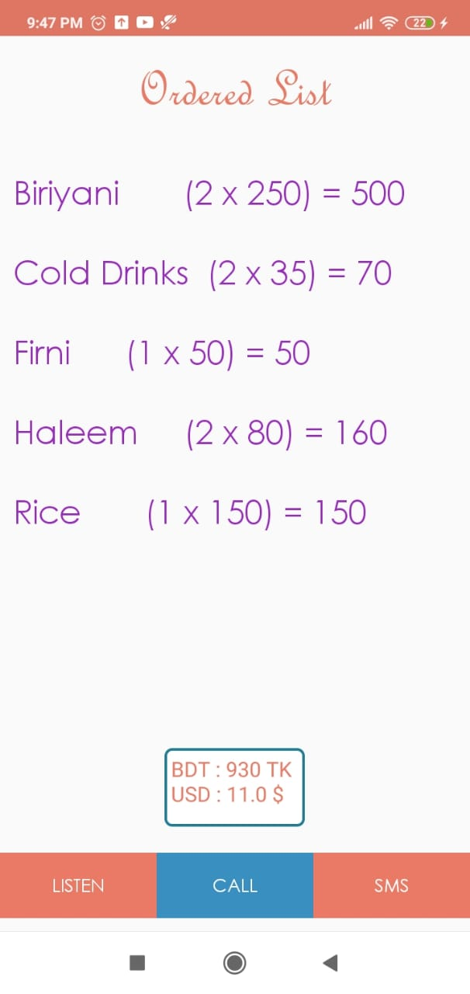

**Fig. 3.** Computation of Total Amount Ordered by a Customer After Placing the Order

List

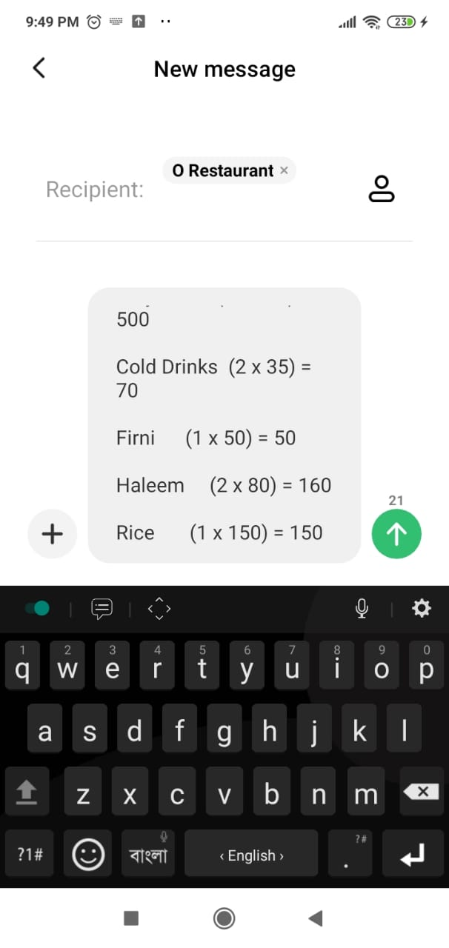

**Fig. 4.** Confirm Order and Send Message

List

1. Summary

With the improvement of technology, online food ordering systems are becoming a popular topic. That is because they are serving the ever-increasing demand for convince. The main purpose of an online ordering system is to provide customers for a way to place an order at a restaurant over the internet. So why is this important? The main reason is that it benefits both the customer and the business. With a website or mobile app, customers can easily browse all the dishes the restaurant has available, customize dishes to their requirements and place an order. It can also save their favourite orders allowing them to easily re-order that in the future. From the restaurant’s perspective, they no longer spend time taking the customer’s order, stop worrying about communication errors and streamline their order management workflow.

1. Acknowledgement

In performing our assignment, we had to take the help and guideline of some respected persons, who deserve our greatest gratitude. The completion of this assignment gives us much pleasure. We would like to show our gratitude **Dr. Shibakali Gupta, Asst. Professor in The Department of Computer Science and Engineering, University Institute of Technology, The University of Burdwan,**for giving us a good guideline for assignment throughout numerous consultations. We would also like to expand our deepest gratitude to all those who have directly and indirectly guided us in writing this assignment.